 | Tip: | Picture:
Week 1: | What’s on your breakfast table?  Now that kids are back in the routine of waking up early for school, we want to start their day off on a good foot by giving them a balanced breakfast. Most of the quick & convenient breakfast items are loaded with carbohydrates and sugar. We want to balance their breakfast by incorporating protein, low sugar carbohydrates and healthy fat.  Sample Breakfast: Breakfast sandwich on English muffin (egg, cheddar cheese & Canadian bacon) or if you are looking for something a little quicker try a smoothie with plain greek yogurt, almond milk berries and 1 tsp nut butter
Week 2: | What’s in your child’s lunch box?  Now that we are balancing breakfast, we want to do the same thing for your child’s lunch! We want to include low sugar snacks, high fiber carbohydrates, lean meats, one vegetable and healthy fats. Stick with water as their beverage.  Sample Lunch: ham sandwich on an arnold’s sandwich thin, cucumber slices, apple with 1 tsp peanut butter  Try using these containers when packing your child’s lunch! | 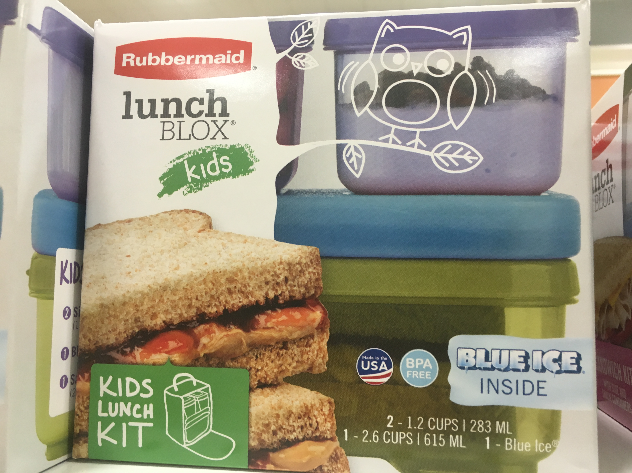
Week 3: | What is your child snacking on?  Many times we gravitate towards something quick like goldfish or a bag of chips as a snack after school. Having carbohydrates alone will not keep your child full and satisfied for a long time. Try to add healthy fat, from nuts and seeds, and protein to their snack.  Sample snacks: hummus with veggie sticks, greek yogurt parfait with 1 tsp nuts and berries or apple slices with turkey and hummus roll-ups | 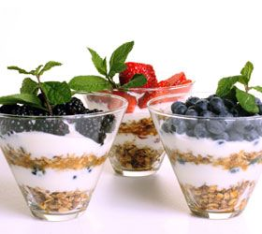
Week 4: | What’s on the dinner table?  The goal at dinner is to incorporate lots of veggies first! Load your child’s plate with veggies and encourage them eat all of those first before moving on to the protein and carbohydrates. Next, have your child eat the protein and at the end of the meal, move towards the carbohydrates.  Sample Dinner: 1+ cups cooked broccoli, grilled chicken & ½ -1 cup mashed sweet potato | 