 | Tip: | Picture:
Week 1: | What should your snacks consist of?  The most ideal snacks are balanced containing low sugar and high fiber carbohydrates, protein and healthy sources of fat. Combining all macronutrients together will help you stay full and satisfied until the next meal.  Tip: plan out your snacks for the week by pre-portioning them into little baggies | 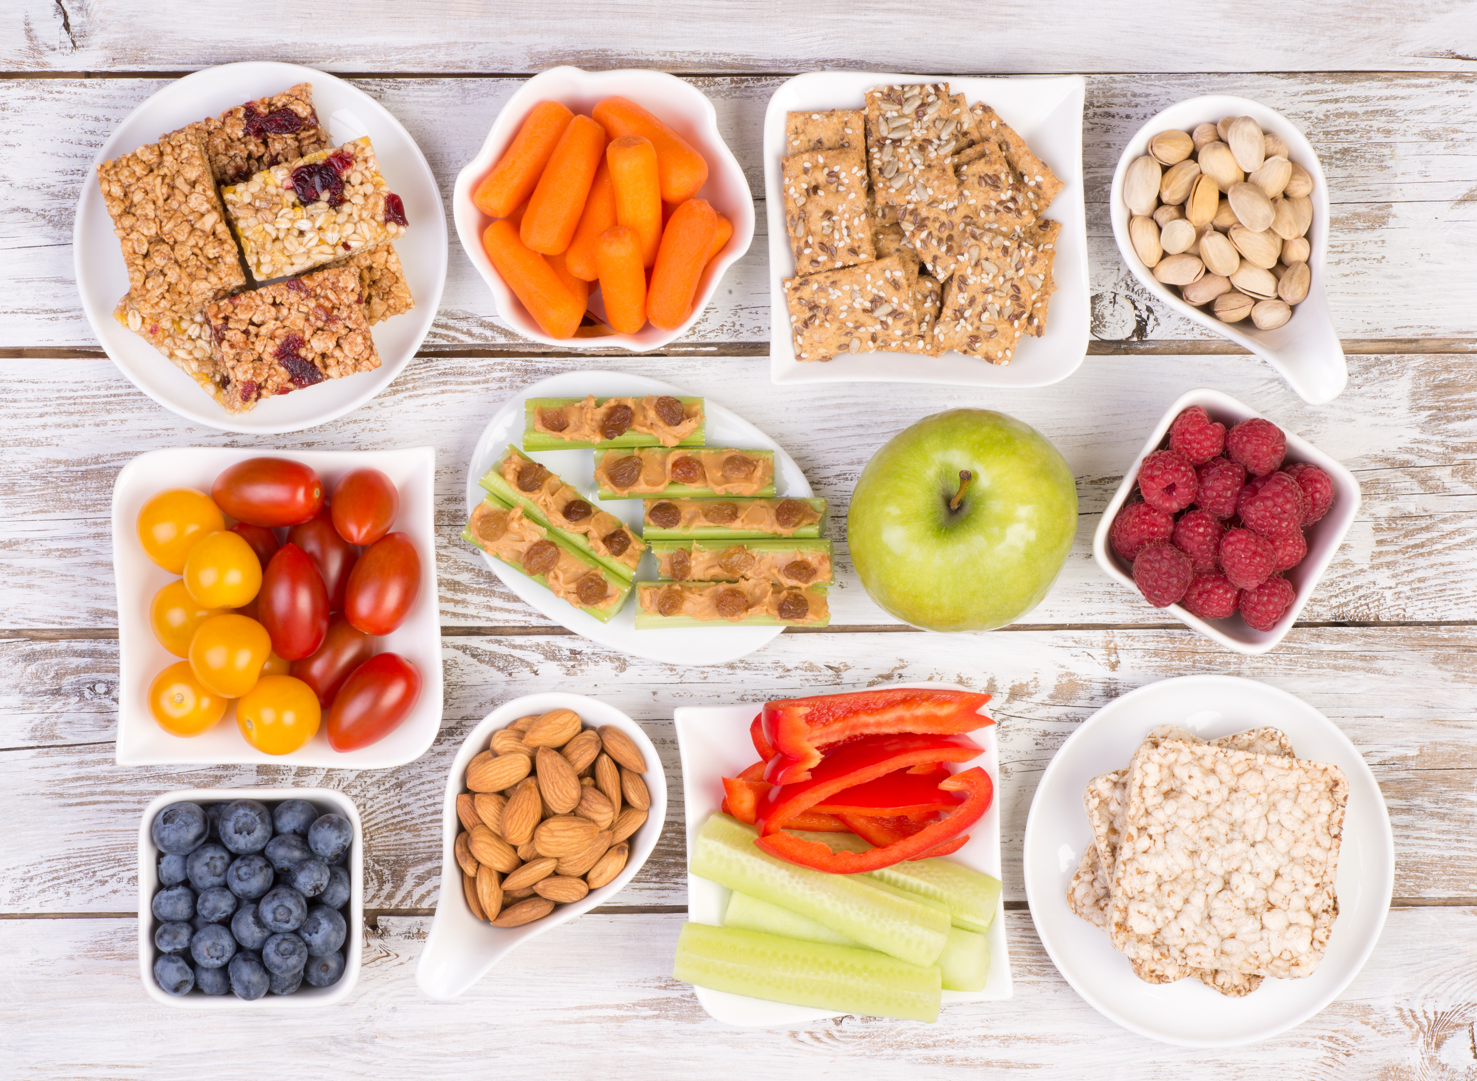
Week 2: | What’s the best bar?  Many bars are loaded with sugar and carbohydrates or only high in protein. You want a bar that’s balanced with carbs, protein and fat. If a bar has sugar listed in the first 3 ingredients, put it back on the shelf.  Tip: Try The Perfect Bar Minis, RX bars or Low Sugar Kind Bars | 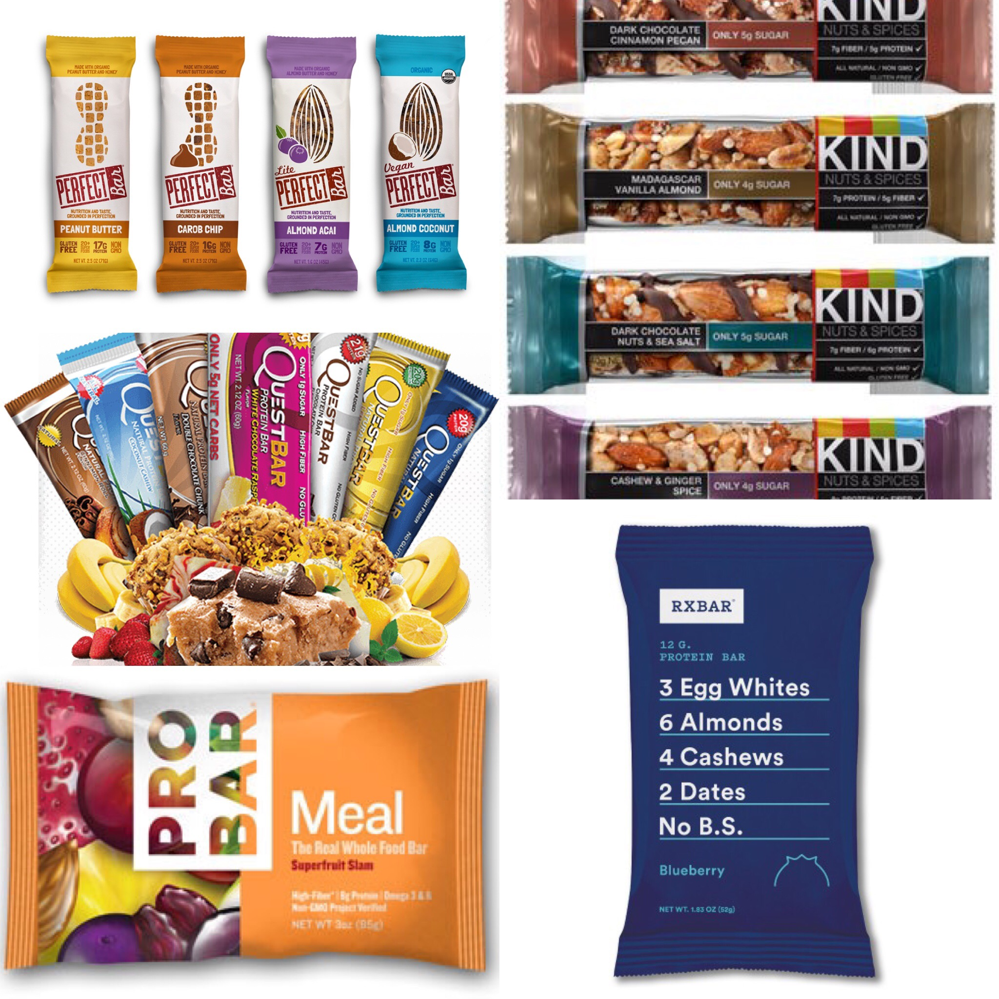
Week 3: | How to plan for success?  When you know you are going to be on the road or traveling, try to bring something with you to hold you over and avoid the drive thru. Try bringing an apple with nuts or a balanced bar. Consider packing a little cooler if you know you will be in the car all day to bring your lunch and snacks with you. | 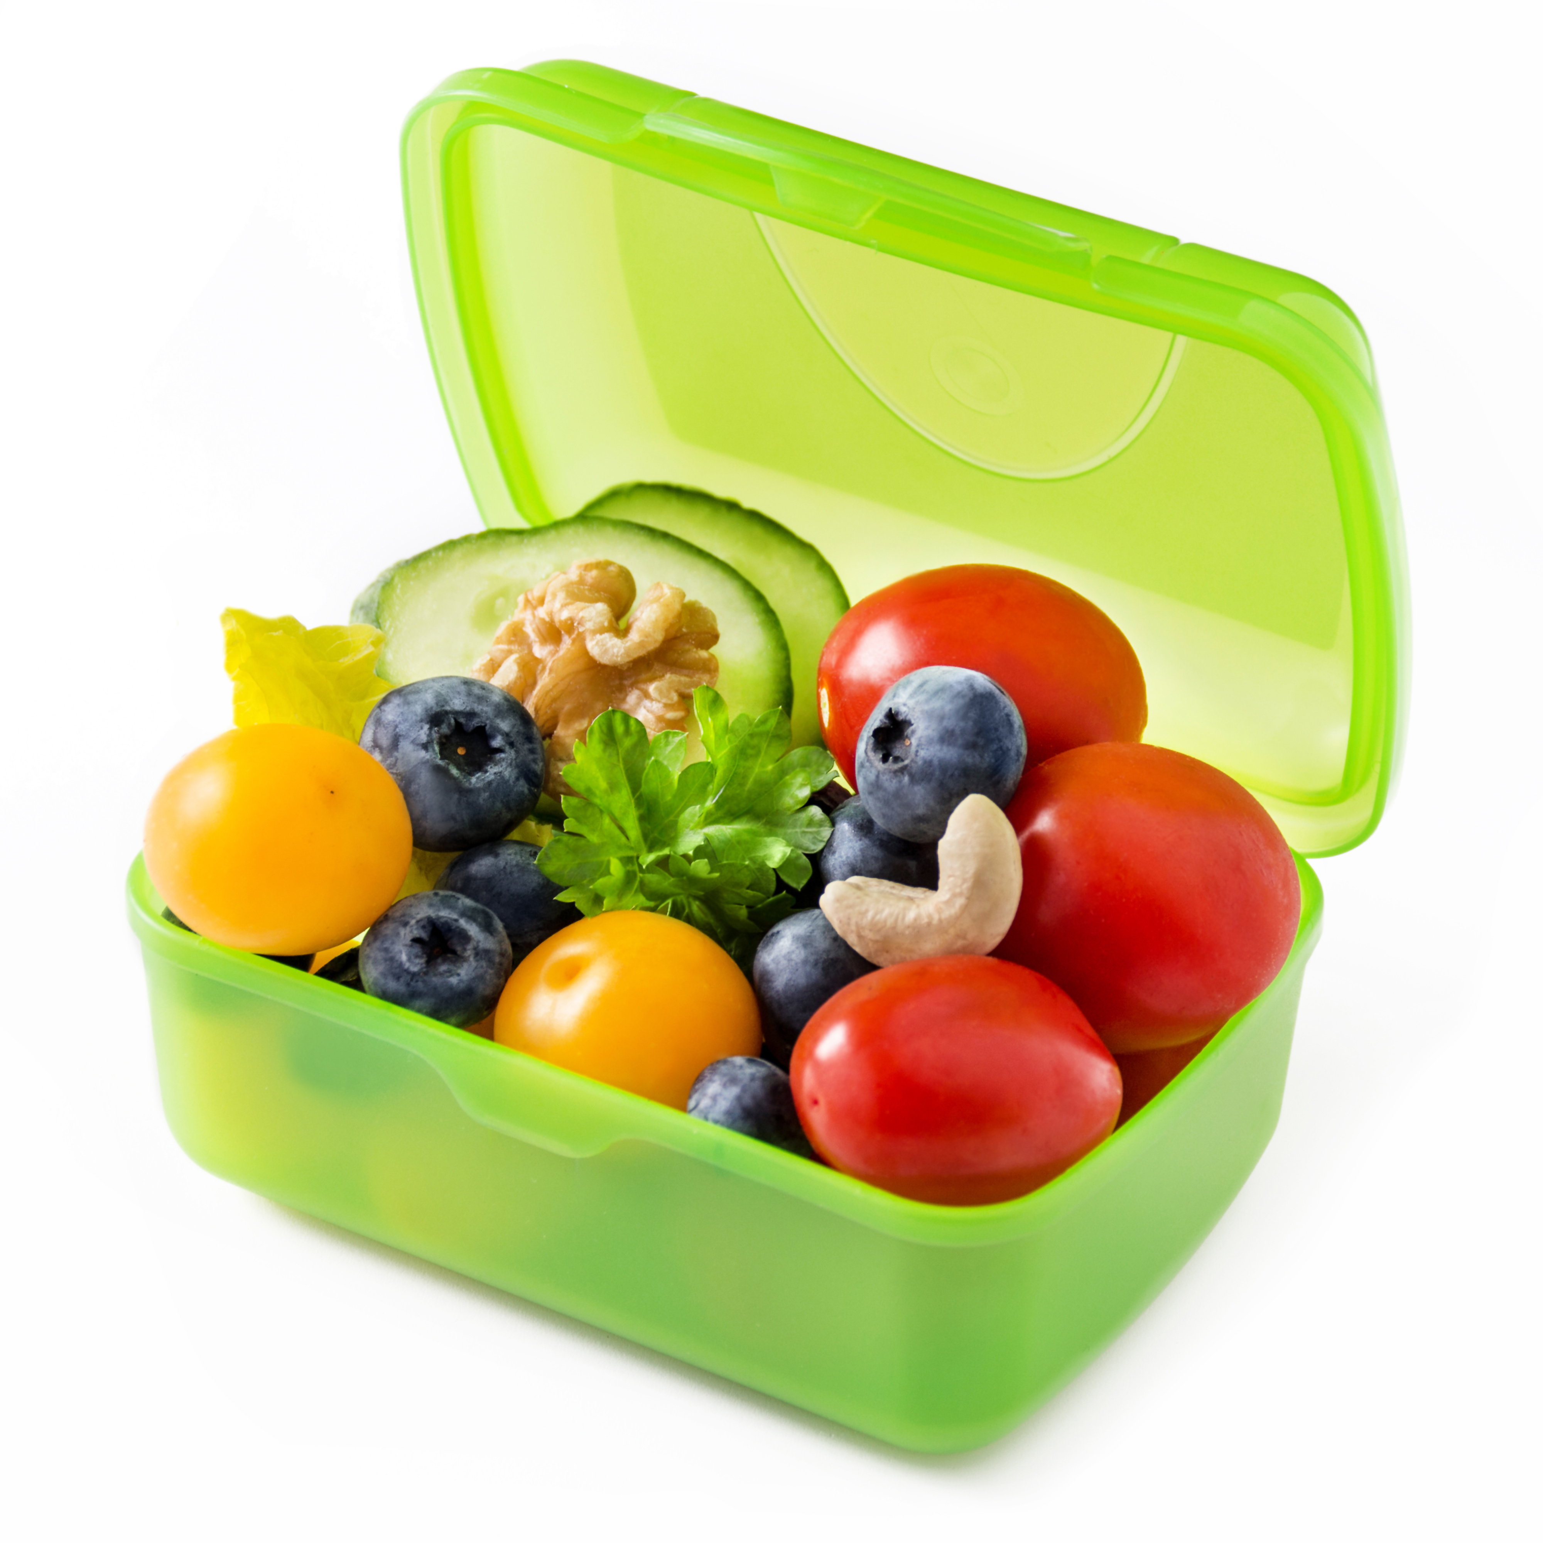
Week 4: | Should you drink your calories?  It is much easier to drink your calories than eat them, which means the calories can add up quick! There could easily be 500-600 calories in one smoothie with all the fruit and other ingredients. Smoothies can be quick and easy options when on-the-go, just beware of how much you are packing into that little cup!  Tip: when making a smoothie just use one serving of fruit, load up on veggies such as spinach or kale and add a little healthy fat from nut butter or avocado. | 