 | Myth: | Fact: | Picture:
Week 1: | If I skip meals, I will lose weight. | Skipping meals causes you to over eat later in the day leading to weight gain. Remember, your brain is 15 minutes behind your belly, which means it takes 15 minutes to realize you are full. If you have skipped a meal and are “starving,” you could end up eating double the amount of calories during that time.  Tip: Set a timer to remind you to eat every 3 hours. Bring healthy, balanced snacks with you during the day to help you stay on track.
Week 2: | If I’m counting my macros and I stay under, I can eat whatever I want. | Just because it “fits your macros” doesn’t mean that it’s the healthiest option or going to help you see the results you are looking for. The best example is over consuming sugar and frequent cheat meals. Sugar causes an inflammatory response and increases bloating around your belly area. Just because you have extra room for carbohydrates at the end of the day, doesn’t mean you should binge on ice cream or candy.  Tip: Stick with low glycemic carbohydrates, fruit in the morning and only 1-2 servings per day. Have your occasional treat 1-2x month and move on. If you are counting your macros, you should space your protein, carbohydrates and fat throughout the day, not saving it for one meal. | 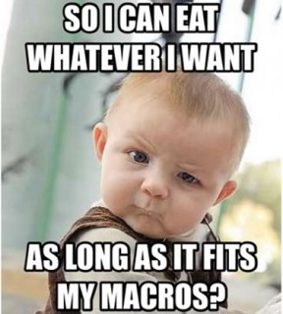
Week 3: | I should only eat protein to help me lose weight. | Eating too much protein puts stress on your kidneys and can cause health issues long term. Having only protein is metabolized quickly and by itself, protein won’t keep you full and satisfied. Working out without carbohydrates in your system can cause your blood sugar to drop leaving you weak, shaky and decrease your performance.  Tips: Focus on including all the macronutrients for meals and snacks: carbohydrates, protein and fat. | 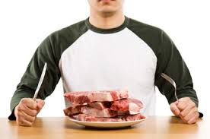
Week 4: | Fat is bad for you. | Not all fat is bad for you. Fat has many important functions in the body. Your brain and central nervous system live off of fat. Fat helps with the absorption of vitamins A, E, D and K and can also be used as a source of energy.  Tips: Try to incorporate plant-based sources of fat into your meals and snacks. You want fats that are high in Omega 3s to help you fight inflammation, increase recover after workouts and increase your HDL (good cholesterol). Here are some examples of good fats: avocado, coconut oil, almonds, walnuts, pecans, cashews, and nut butters. | 