 | Tip: | Picture:
Week 1: | Proper hydration and adequate water intake plays a vital role in reaching weight loss goals! Water is needed for all metabolism processes including breakdown down fat.  Water intake goal: 80+ ounces per day!  Tips to increase water intake: carry a water bottle with you, drink out of a straw, track your water intake, drink a cup water with every meal and snack | 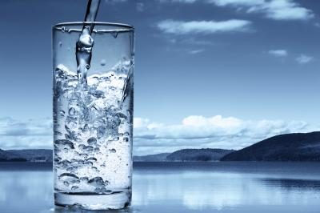
Week 2: | Beware of sugary summer treats! Watermelon is a popular item during the summer which contains 10 grams of sugar and only 1 gram of fiber per cup.  Try to stick with one cup of berries, which are a much lower glycemic snack and a refreshing snack. | 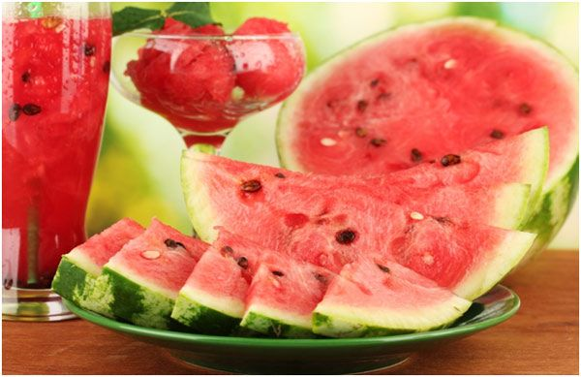
Week 3: | Set yourself up for success by bringing pre-portioned snacks with you instead of grazing all day. Mindless snacking leads to overconsumption.  Try logging your intake using MyFitnessPal to stay on track to meet your goals. | 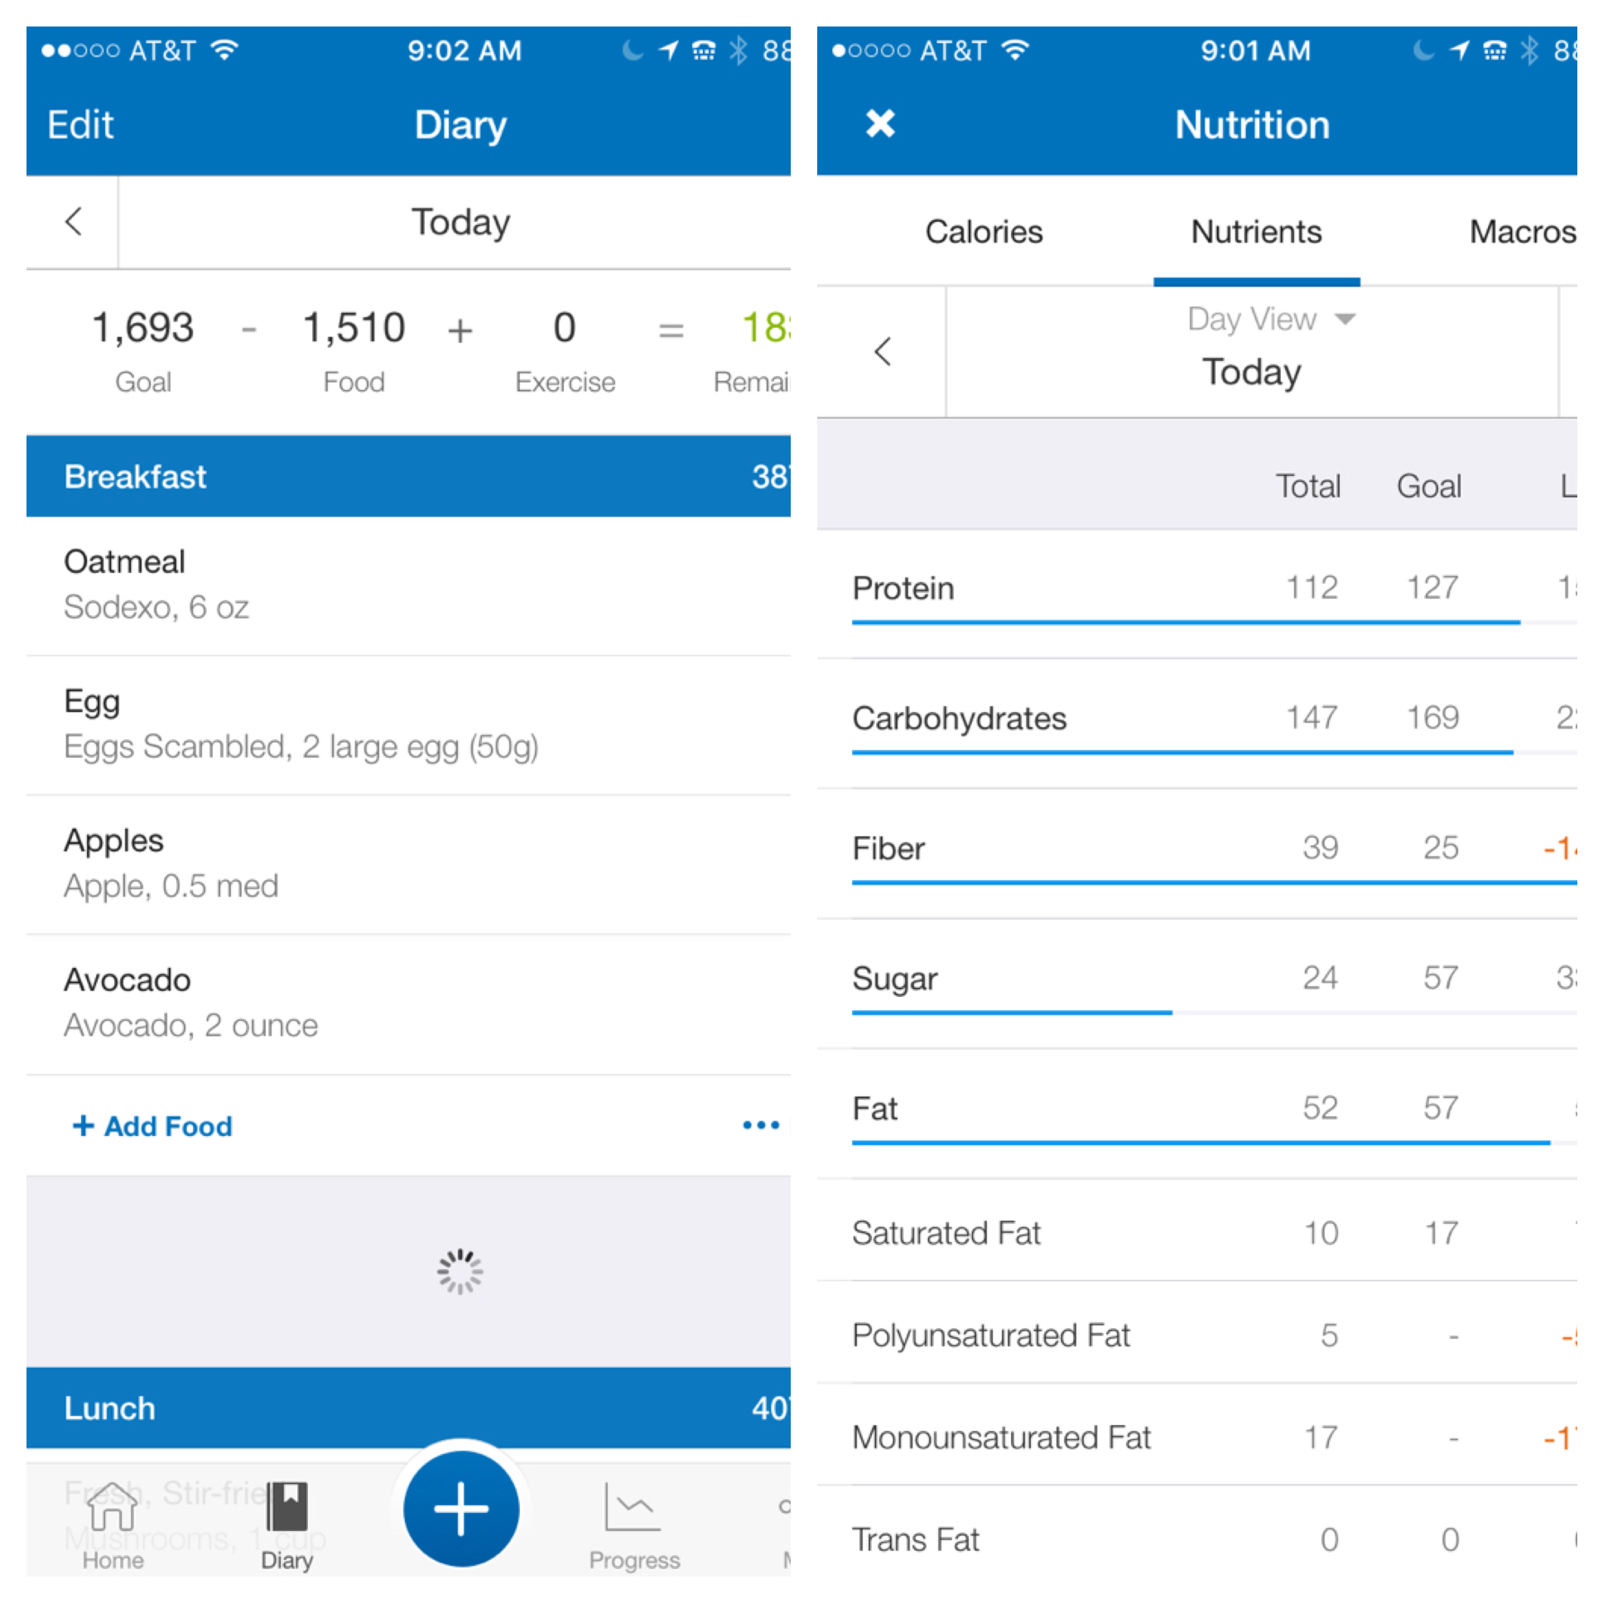
Week 4: | Beware of the refreshing summer alcoholic beverages that are loaded with sugar. Did you know that one Rum Runner contains 39 grams of sugar, that’s about 10 teaspoons of sugar in ONE drink! Juice contains a high amount of sugar which causes a large inflammatory response, bloating and weight gain! Try to stick with a sparkling water flavored with fresh fruit. | 