 | Tip: | Picture:
Week 1: | Are you interesting in juicing?  There’s a lot of hype about the health benefits of cold-pressed juices, but the problem with juicing that not everyone knows is the amount of sugar in them. A typical 12oz juice from Jamba juice contains 35g of sugar. A can of coke contains 39g. Yes, they are all natural sugars, but your body will convert most of this sugar into fat. A good tip is to stick with the whole fruit over juices. This will decrease the amount of extra sugar you will intake while still providing all the health benefits. | 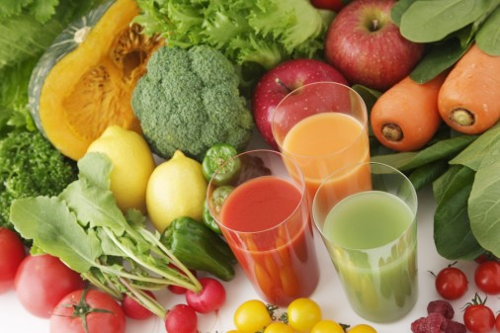
Week 2: | Healthy Fats to Enhance Your Recipes  Everyone NEEDS fat! Inadequate fat intake can lead to lean muscle tissue breakdown, muscle fatigue, accumulation of fatty tissue, lack of energy, and poor athletic performance. Try adding these healthy sources of fat to your favorite dishes: chia seeds, pumpkin seeds, hemp seeds, and unprocessed coconut oil. About an ounce of the seeds and 1 teaspoon of the oil is the ideal amount to add. | 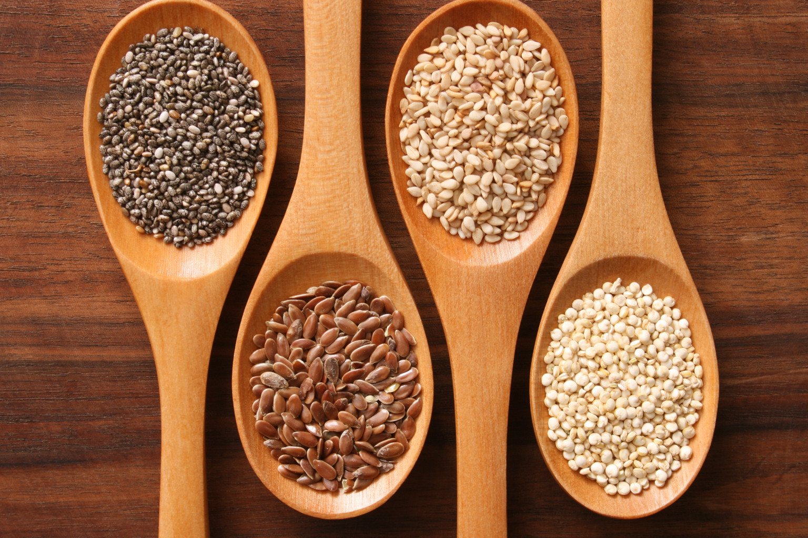
Week 3: | Post Workout Recovery  You have a 30minute  window after your workout for optimal recovery. Ideally 20-25g of whey protein with a carbohydrate such coconut water or almond milk is best. Make sure to check the nutrition label to make sure it is not packed with artificial sweeteners
Week 4: | Sodium Substitutes  Sodium causes your body to retain fluid. Many of the foods you find down the aisle is packed with sodium, Try shopping the perimeter of the grocery store and seasoning your food with Ms. Dash, garlic, fresh herbs, lemon, and lime.

Questions of the Day + Script
What’s your favorite post workout recovery? | - 30 Minutes window  - Whey protein and add carbs!  - Liquids over solid food  - Examples: protein shake with coconut water or shake mixed with water + fruit buddy
What’s your go-to snack? | - Benefits: prevents over-eating later in the day and keeps you full and satisfied  - Recommend to pair protein + carbs + healthy fat  - Examples: hard boiled egg + ½ apple or hummus + turkey roll up

