 | Tip: | Picture:
Week 1: | Tis’ the season of baking. Try these  Healthy Recipe Substitutions to cut down calories and fat in your favorite recipes:  - Sugar unsweetened applesauce  - Butter avocado  - Flour black beans (brownies)  - White flour coconut/almond/wheat flour  - Eggs egg whites or chia seeds + egg whites  - Sour cream greek yogurt  - Chocolate chips coco nibs  - Mashed potatoes mashed cauliflower  - Pasta zucchini noodles or spaghetti squash | 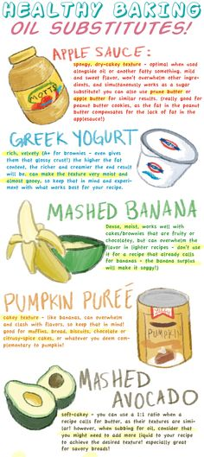
Week 2: | 3 Tips for Healthy Kids:  - Balance Your Plate: incorporate a healthy source of carbs, protein and fat with every meal and snack  - Portion Control: try to have ½ plate fruits and veggies, ¼ starch and ¼ lean protein  - Cut out the sugary drinks and sacks: juice and “kids” snacks are loaded with sugar causing energy levels to go high then low. The average juice contains 8+ teaspoons of sugar! Stick with water, low fat milk or almond milk and a piece of fruit on the side. | 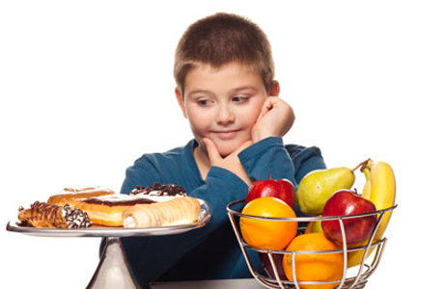
Week 3: | What is a Realistic New Year’s Resolution?  The #1 New Year’s Resolution is to lose weight. Is that yours?  Try taking your weight loss New Year’s Resolution a step further and writing down a realistic goal of achievable weight loss.  Realistic weight loss is 1-2 pounds per week. The fad diet and infomercials that claim more than that are not helping you achieve long term realistic FAT LOSS!  After you set your goal, come up with a plan.
Week 4: | 5 Steps To Achieving Your Weight Loss New Year’s Resolutions:  - Set Realistic Goals  - Prep For Success (meal prepping is one of the single most important things you can do to stay on track)  - Have an accountability system in place (logging your food and having someone to “answer to” helps you more likely to stay on track)  - Tack Your Progress (take measurements, pictures, body fat)  - Revise Your Plan (as you achieve your goals, set new ones)!

